LAB ASSIGNMENT V : HUERISTIC EVALUATION
SYSTEM EVALUATED : __________
Groups members NAME : ………………………………………………….
**Evaluation to be done by other Group
PART I : HUERISTIC EVALUATION BASED ON NIELSEN'S 10 GENERAL PRINCIPLES FOR INTERACTION DESIGN. (0 is lowest and 10 is highest)
S.No. | Heuristic Evaluation Parameter | Mention Violation if any | Severity 0-10 (0- minimum and 10 is maximium) | Ways to improve
1 | User Control: Interface will allow the user to perceive that they are in control | If camera permissions are denied, re-enabling requires browser settings | 9 | Enable camera permissions
2 | Human Limitations: Interface will not overload the users cognitive, auditory and motor skills | Cuts overload ad banners and repetitive schemes for simple and clean color scheme. | 9 | Suppresses pop-up banners. Maintains simple grid
3 | Accommodation: The interface will fit the way each user group works and thinks (personas) | Fit for any type of users and shows different currency rates for NRI users | 10 | Includes headers so users can switch manually any time
4 | Linguistic Clarity: Interface will communicate as efficiently as possible | Easy cleans labels and clear metal clarity | 9 | Add hover tooltips for international users
5 | Aesthetic Integrity :The interface will have an attractive and appropriate design | Features luxury visual using dark forest green with no human model | 10 | Ensures gold accent maintains balance between beige and dark forest green
6 | Simplicity: The interface will have a simple design | Quick doorstep return, navigation and search makes easy user flow | 10 | Ensure modal overlays remain lightweight
7 | Predictability :The interface will behave in such a manner that the user can accurately predict what will happen next | Known luxury icons and easy navigation flow | 10 | Visually differentiate the live gold rate ticker with a dynamic badge indicator so users recognize it as real-time market data
8 | Accuracy: Interface will be free from errors | Real-time gold rate ticker, exact itemized price breakdowns, and official BIS Hallmark badges ensure pricing accuracy. | 9 | Display real time boutique store pieces left
9 | Technical Clarity: Interface will have the highest possible fidelity. | High-fidelity UI presentation across desktop and mobile, with hidden web scrollbars | 8 | Optimize camera asset loading in under 1.5 seconds on 4G/5G mobile connections.
10 | Fulfillment : The interface will provide a satisfying user experience | Solves online jewellery sizing anxiety through the interactive Virtual Try-On and live video consultations | 10 | digital authenticity certificate vault access in the user profile.
11 | Consistency: Interface will be consistent | Strict color palette, typography. Champagne Gold icon strokes, and uniform card padding across all 90 routes. | 10 | Locked component spacing in Figma across both desktop and mobile viewports.
12 | User Support: Interface will provide additional assistance as needed or requested | Offers multi-channel support including 24/7 live WhatsApp chat, direct video consultation booking, and a dedicated help center. | 9 | Introduce AI assistant prompts when users customize complex engraving.
13 | Precision: The interface will allow the users to perform a task exactly | Visual scale slider exact karat toggles, and GPS store locator distance metrics. | 9.5 | Provide numerical precision for exact distance and time to reach store
14 | Forgiveness: Interface will make action recoverable | Features 1-click cart item removal, buttons, 1-click doorstep return initiation, and smart 404 recovery. | 9.5 | Undo button and notification when Item removed from wishlist or shopping cart
15 | Responsiveness: The interface will inform users about the results of their actions and their interface status | Live filter grid, smooth animations, live gold rate, updates on wishlist/cart | 10 | Vibrations on mobile devices when saving an item
 | Total Score |  | 142/150

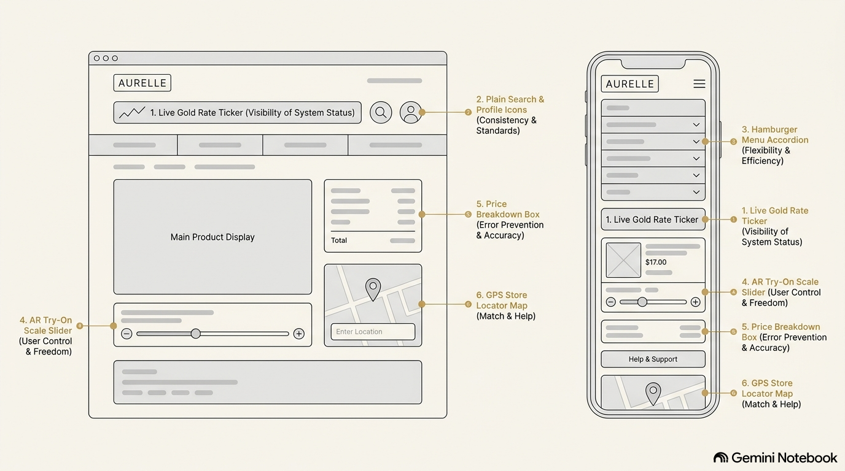

PART II : List out any other points that you may have missed out . (Other than Nielsen’s Principles)

S.NO | OBSERVATIONS | COMMENTS
1 | Stores Near Me Live Inventory Check | Integrates physical boutiques into the digital experience live in-store stock checking.
2 | Strict No-Human-Model Display Policy | Eliminates model-related sizing bias and keeps customer focus purely on craftsmanship and metal purity.

Students Evaluation Team : group that is evaluation ………………………………………………………………………………..

